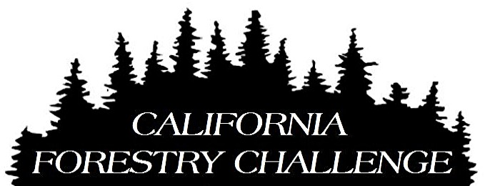

2015 PRE-REGISTRATION FORM

Please complete this form and e-mail to dianedealeyneill@gmail.com

School Name: ___________________________________________________
Primary Teacher / Chaperone: ______________________________________
Cell phone number: _______________________________________________
Approximate Number of Students Attending: __________________
If you are a new participant, and were referred by another teacher, please put his/her name here: ______________________________________
If you are a returning participant, please list new schools and teachers you suggest we contact: ____________________________________________

Which event do you plan to attend? (Mark with an “X” or use numbers to list in order of preference if you are not sure.)

_FULL_ Shasta Forestry Challenge – September 23 to 26 - $100/person

_FULL_ Sequoia Forestry Challenge – October 7 to 10 - $100/person

______ El Dorado Forestry Challenge – October 14 to 17 - $115/person

_FULL_ Santa Cruz Forestry Challenge – Nov. 4 to 7 - $165/person

______ San Bernardino Forestry Challenge – Nov. 18 to 21 - $150/person

Will you need registration fee assistance? (Highlight your response) YES / NO

I will also need assistance for: substitute pay, transportation. (Highlight all that apply.)

Thank You!

